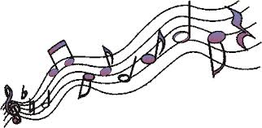**Teacher Notes**

**Congratulations to Morgan and Ramel for representing our class on Wake Robin’s Green Team.**

**Congratulations also go out to Jackson and Rondel for representing our class in Wake Robin’s Student Council! Way to go!**

**We had our first ABC Assembly this week. Awards went to: Academic-Thomas, Behavior-Morgan, and Citizenship-Elaina. So proud of you!**

**Rock Star**

**Learning Tops the Charts!**

**Reading: The class read *Pepita Talks Twice.* The students continued to work on their Read to self-stamina. Dr. Kingsley listened to many of the students read.**

**Language: This week we took a look at two types of sentences statements and questions.**

**Math: Math got hard this week. We worked on counting money and counting change. This was really difficult for many. Extra practice at home is essential! We took our first topic test. Please see the test in the attached packet.**

**Science: Our class learned about plant parts and their functions.**

**Social Studies: We used our compass rose to help us figure out cardinal and intermediate directions.**

**Health: Our class talked about keeping your eyes, ears, and nose healthy. We also discussed reading labels on items to know if they are safe.**

**Spelling: The kids sorted words and learned about spelling patterns.**

**Writing: The class looked at examples of good personal narrative writing.**

**Key Words**

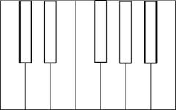

**use using eat eating close moan wave writing dreaming looking dream skate closing trading cleaning clean write moaning trade skating waving look mail mailing**

All Access Pass to Learning

Dr. Kingsley’s Third Grade

Email: [kelly.kingsley@bpsne.net](mailto:kelly.kingsley@bpsne.net) August 30, 2013

Website: www.mrskingsleysthirdgrade.weebly.com

Concert Tour Schedule

Monday: No School

Tuesday: Day 7 Art

Wednesday: Day 8 P.E. and Music

Thursday: Day 1 Media

Friday: Day 2 P.E. and Music, Spelling Test